Clink 256Trx, 2rank CDLC
First rez:
Win=32 WinLeft=0
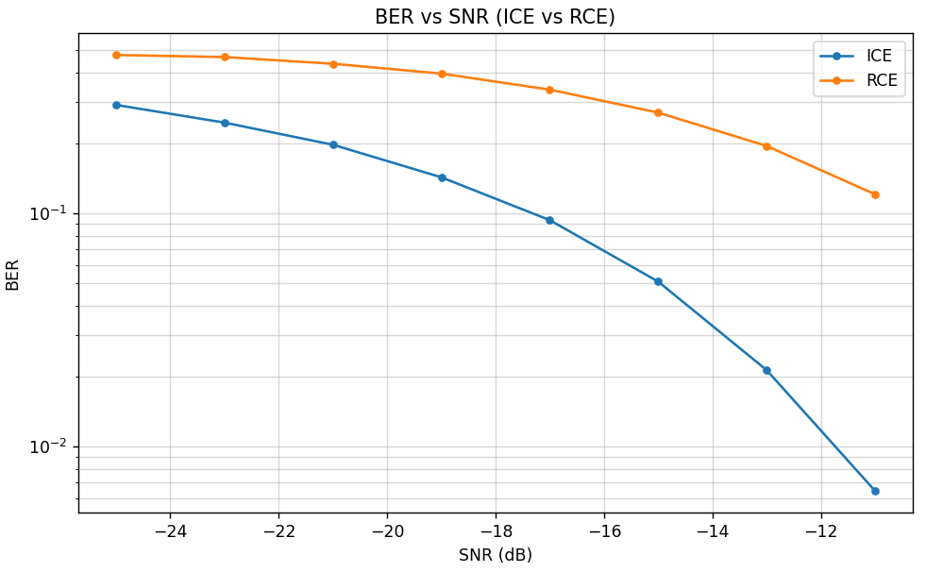
Win=8, WinLeft=4 (+0.5dB gain)
